Memorandum of Understanding (MOU)
For
Pigeon Lake Watershed Association (PLWA)

Funding to Purchase Native Plants

Address of the property: __________________________
Property Owner:___________________________

Details pertaining to the entire project can be accessed at www.plwa.ca/naturalize-your-lot/assessing-your-lot

The conditions and intention of this agreement is to ensure that all Parties named in this agreement are working from a mutual understanding.

The Parties and corresponding representatives involved are:

- The Property owner: _____________________________
- The Pigeon Lake Watershed Association (PLWA): Carson Hvenegaard, Project Manager

Intentions for the funding:

- Contribute to native vegetation in the Pigeon Lake watershed to support resilience of the land to prevent floods and droughts, slow and filter runoff into Pigeon Lake, reduce the intensity and frequency of algal blooms, and improve biodiversity.
- Provide information to Pigeon Lake Watershed property owners to allow them to:
  - Learn about native plants and their environmental benefits
  - Decide what native plants they want on their properties
  - Find suppliers for native plants
- Provide funding to allow property owners to purchase native plants to be planted on their properties

Roles & Responsibilities:
The Property Owner’s roles and responsibilities are to:
- Be a registered member of the Pigeon Lake Watershed Association. (Become a member here)
- Complete a clean runoff assessment before they are able to receive reimbursement for purchased plants. (Book an assessment here)
- Sign and return this MOU
- Submit a receipt of purchased plants and provide proof that the species of plants purchased are native to Alberta. PLWA will not reimburse you for non-native plants or for any labour or other materials.
- Plant the native plants on their property in the Pigeon Lake Watershed. Confirm this by conducting a site visit with PLWA staff and taking pictures of the plants.
- Assume any and all associated risk for the project.
- Apply as needed for any required municipal, provincial or federal approvals. Be sure any municipal bylaws are recognized and met and inform the municipality as required and appropriate.
- Highlight the work to neighbours and visitors, as opportunities arise, and report those interactions back to the PLWA.
- Release the PLWA to include learnings from this project in any and all formats, for educational purposes, in the furtherance of our mission.
The PLWA’s roles and responsibilities are to:
- Provide guidance and information about native plants and suppliers.
- Reimburse the property owner up to the amount of $5,000 for the purchase of native plants, only after all conditions have been met including all receipts submitted and a site visit conducted to confirm the plants were planted in the Pigeon Lake Watershed.

Process and Timeline:
- Complete and return this MOU as soon as possible.
- PLWA will provide property owners with information about native plants and native plant suppliers.
- Winter: Property owners will research native plants and suppliers and give PLWA an estimate of the costs of the plants they plan to buy.
- The property owner purchases their native plants. We recommend contacting the supplier and ordering the plants during the winter or early spring to ensure you get the plants you want and so costs can be known as soon as possible.
- Spring 2023: The property owner submits receipts, plants their native plants, and organizes a property visit with PLWA staff. Following the property visit and once any other requirements are met, PLWA will provide reimbursement to the property owner.
- The deadline for submitting receipts for this phase of the project is June 31, 2023.

Communication
PLWA will:
- Document the progress by taking pictures during the site visit. Property owners will have the right to remain anonymous and withdraw any pictures of themselves that they wish.
- Highlight the project in communications and in clean runoff presentations e.g. PLWA Annual General Meeting, PLWA Annual Report, stewardship summary on PLWA website. To protect the homeowners’ privacy, information will be presented without direct reference to the specific location.
Property Owners Will:
- With this agreement, the property owner allows the PLWA to document and use the photos from the project as set out above.

The following people have reviewed and agreed to the intentions and conditions laid out in this MOU.

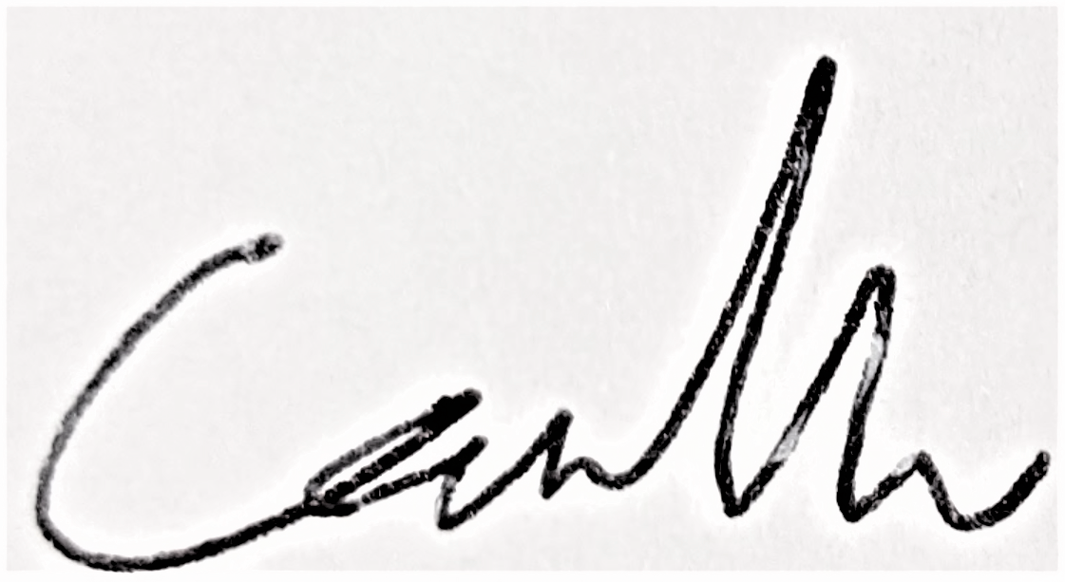
Property Owner: _____________________________ Date: ________________________

PLWA: ______________________________________ Date: __November 14, 2022_____

